WEEK 10 WEEKLY REPORT

Joeverlyn Capute

WDD330

1. What did I do since the last meeting?
2. What am I going to do next?
3. What are my blockers?

I have created new images for my Final Portfolio project. I wanted to use the same yellow background I made last time, but I couldn’t remember where I download the image so I just use a different background image (now the color motive is blue). Images are from Unsplash, pixels and pixabay.

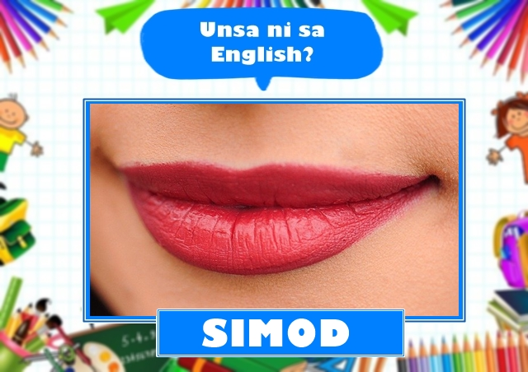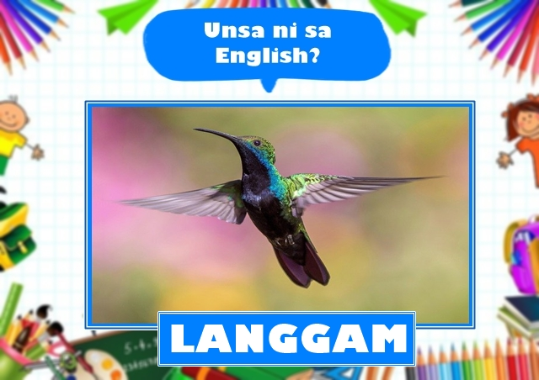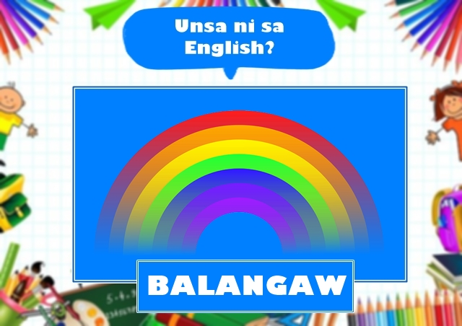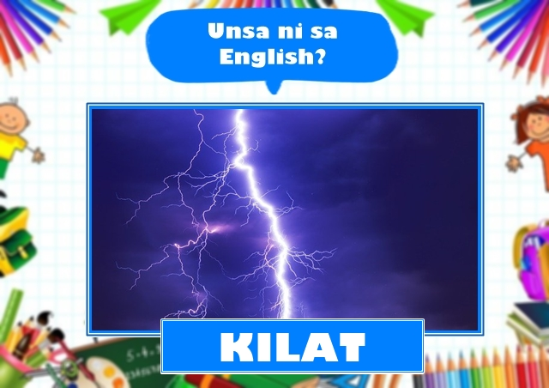

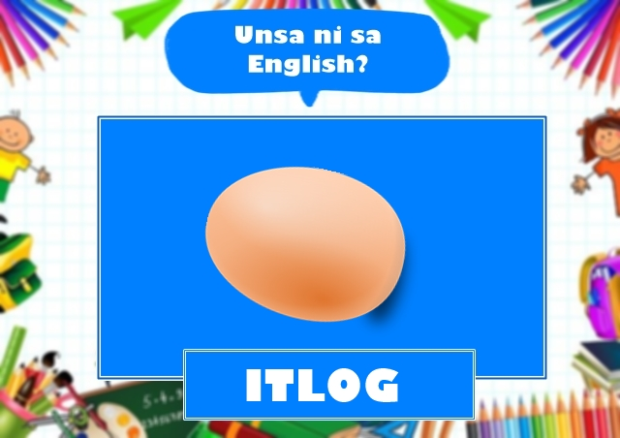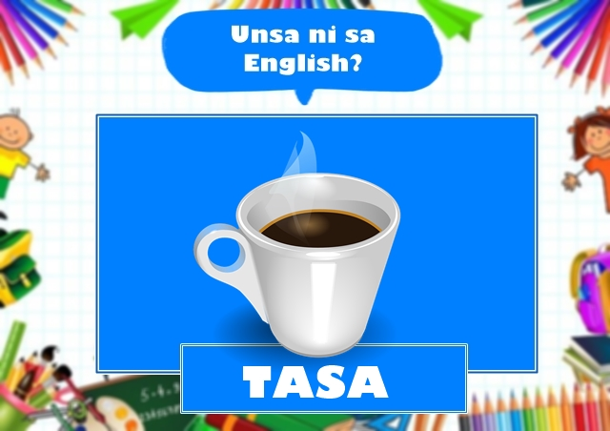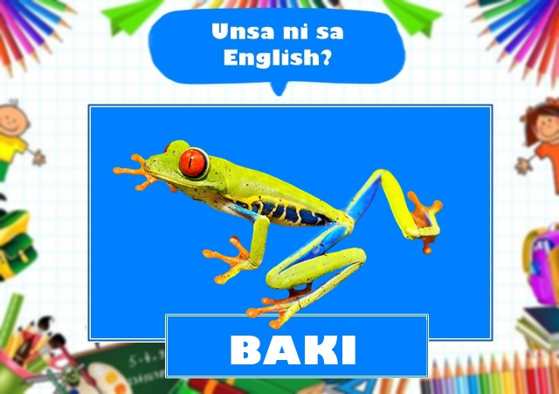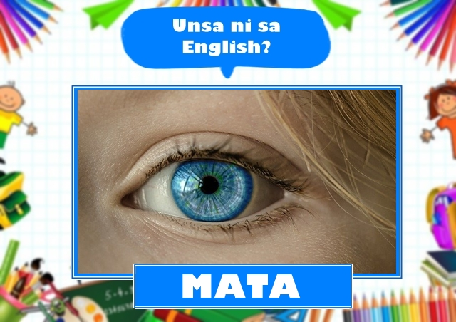

I have already made my HTML, CSS, Hover, animations get to work. So far, I made 10 design images to be used. They’re just simple so that a 3-year-old child could answer.

This week my goal is to obtain the player name and calculate the score. I wanted to add more images so that the player will have more fun playing the app.

I was able to make a sample of the validating form <https://awe19001.github.io/WDD330/week10/form/form.html>

But my problem is I did not really quite get the reading - Using Fetch. I was confused when I read the reading assignment and so what I did is that I search for some videos regarding using fetch to help me understand what it does.